CMP6233 – Modern Datastores & Data Protection

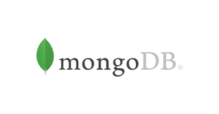

Dr. Anuoluwapo Adewuyi

Week 2: Introduction to MongoDB and the Mongo Shell

Week | Practical Lecture | Lab Exercises | Additional resources | Assessment 2 Schedule
2 | Introduction to MongoDB and NoSQL database. Data types. | Installing the MongoDB shell. Creating a MongoDB cluster/collection/document |  | Create Cluster and schema for assessment

2.1 Introduction
MongoDB is a Document Database and stores BSON ("Binary JSON" is a binary form for representing simple or complex data structures including associative arrays (also known as name-value pairs), integer indexed arrays, and a suite of fundamental scalar types). Stores data records in Collections and documents.

mongoDB Naming Restrictions:
There are restrictions on collection, document and field names, below are some of the main naming rules.
See: https://www.mongodb.com/docs/manual/reference/limits/#naming-restrictions

Restriction on Collection Names
Mongo database names are not case sensitive (they are case insensitive). However, in systems using Microsoft Windows, database names cannot contain the following characters:
/\. "$*<>:|?
Database names:
- cannot contain the null character,
- they cannot be empty
- must have fewer than 64 characters.
Collection names should begin with an underscore or a letter character.
Collection names cannot:
- contain the $
- be an empty string (e.g. "")
- contain the null character
- begin with the ‘system.’ prefix, or a prefix reserved for internal use
The maximum length of the collection namespace, which includes the database name, the dot (.) separator, and the collection name (i.e. <database>.<collection>), is 120 bytes.

Restriction on Document and Field (attribute) Names
- document and field names cannot contain the null character
- Use of dots (.) and the dollar sign ($) is discouraged although newer versions permit their use in field names (see: Field Names with Periods and Dollar Signs)

Restrictions on _id field
- The field name _id is reserved for use as a primary key; its value must be unique in the collection, is immutable, and may be of any type other than an array or regex. If the _id contains subfields, the subfield names cannot begin with a ($) symbol.

2.2: Learning Plan:
Add the following activities to your learning plan to be completed by next week.
- Download and Install the Mongo Shell
- Create a Mongo database from a given design/schema
- Load given data into a Mongo database
- List some of the documents that were loaded into your Mongo database.

2.4: Lab Exercises:
It is recommended that you download and install MongoDB and the Mongo Shell on your personal computer, so that you can work on this module outside of lab sessions. Hence this part of the lab exercises can be completed in or outside of class.

Installing MongoDB:
For this module install the Community Server edition
Online Instructions:
- https://www.mongodb.com/docs/manual/administration/install-community/
Download page:
- https://www.mongodb.com/try/download/community

Installation Instructions:
For your personal laptop:
- Download the .msi (Windows) or .tgz (MacOS) package and install
For university laptops (Windows):
- Download the .zip package and extract
- Go inside the extracted folder so you can see the Readme file and the ‘bin’ folder and create a folder named ‘data’. Inside the ‘data’ folder create another folder named ‘db’
- Open a cmd window (see below ‘Running the mongo shell’ section) and type ‘cd’ followed by the path to the folder where you extracted MongoDB (e.g., if you extracted MongoDB in the ‘Downloads’ folder type cd Downloads\mongodb-win32-x86_64-windows-8.0.4 )
- Then type .\bin\mongod.exe --dbpath=".\data\db" to start MongoDB server

MongoDB Atlas:
Alternatively, you can use the cloud version of MongoDB (MongoDB Atlas) and quickly setup a cluster on the cloud. Register for an account (https://www.mongodb.com/cloud/atlas/register) and watch this video (https://www.youtube.com/watch?v=VkXvVOb99g0) for more instructions.
Note: It is recommended that you learn how to install and run MongoDB on a client machine, as well as using the MongoDB Atlas version as part of this module.

Installing the mongo shell (mongosh):
The mongo shell is included as part of the MongoDB Server installation when installed via Homebrew. MongoDB also provides the mongo shell as a standalone package.
Online instructions:
- https://www.mongodb.com/docs/mongodb-shell/install/
Download page:
- https://www.mongodb.com/try/download/shell

Installation Instructions:
For Windows:
- Download the .msi package and install
For MacOS:
- Download the .zip file depending on your platform (M1 or x64)
- Follow the instructions here https://www.mongodb.com/docs/mongodb-shell/install/#install-from-.zip-file-1

Running the mongo shell
To run the mongo shell you will need to type mongo from the command prompt
On a PC: Start the Command Prompt using the Run window (all Windows versions) One of the quickest ways to launch the Command Prompt, in any modern version of Windows, is to use the Run window. A fast way to launch this window is to press the Win + R keys on your keyboard. Then, type cmd and press Enter or click/tap OK You should see a >
On a Mac: Double-click Terminal. You may have to scroll down to find it. The Terminal application will now launch to the command prompt. You should see a $
Throughout this guide I will use the PC prompt > (if you are using a Mac you will see a $ but type in the same instructions.

Running the mongoDB - mongod
MongoDB is almost always run on a network server that clients can connect to and perform operations on. To start the server, run the mongod executable mongod. As you will not have a server set up, for this course, we will start by letting mongoDB set up a test database for us. Later on you will be setting up your own mongoDB database.
This session we are focusing on introducing the mongoDB Shell that enables interaction with a mongoDB. The mongoDB shell is where most of the mongoDB development is performed and hence it is essential that you get experience in using it.
To start the mongo shell from the command prompt type
>mongosh database name
For my database which I created above I would type
>mongosh oeplayDB
It should respond by telling you which mongo shell versions you are running. It will try to connect with the server where oeplayDB is located. It will also warn that I can only read and write to this database because I have not set any options. We will be looking at the options in another session.
The shell is a full-featured JavaScript interpreter, capable of running any JavaScript programs. Lets us start with running some simple JavaScript programs. You type in the text after the command prompt which should automatically be there in the command window you are running from. Remember on a PC you can only cut and paste from right click and not through shortcut keys.
> “Hello World”
The system should respond by writing Hello World on the next line.
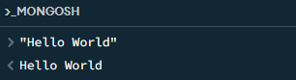
Next, we will perform some basic math:
> x=2
2 (This is what the mongo shell will display)
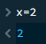
>y = x + 3
5
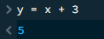
We can also use all the standard JavaScript libraries.
> Math.sin(Math.PI/2)
1 ( you should know that the sin $π/2$ = 1)
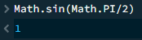

We can also define and call JavaScript functions:
(if you type return after typing in a line of code in the mongo shell you will get a newline and the three dots)
>function factorial (n) {
...if (n<= 1) return 1;
...return n*factorial(n-1);
...}
> factorial(5)
120 (this is the answer)
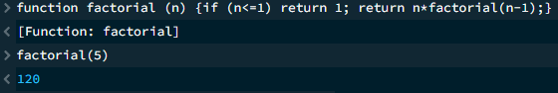

JavaScript script
var data1={
name:'Data1',
work:'student',
No:4355453,
Date_of_birth:new Date(1996,10,17)
};
var data2={
name:'Data2',
work:'student',
No:4355453,
Date_of_birth:new Date(1996,10,17)
};
var Data=[data1,data2];
db.my_collection.insertMany(Data)
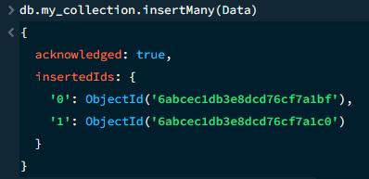
db.my_collection.find()
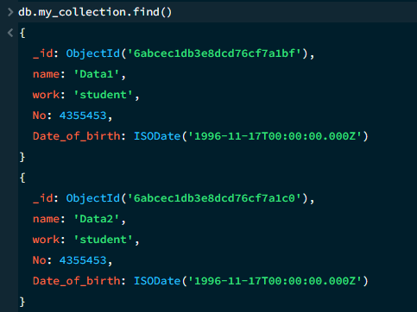
printjson(Data)
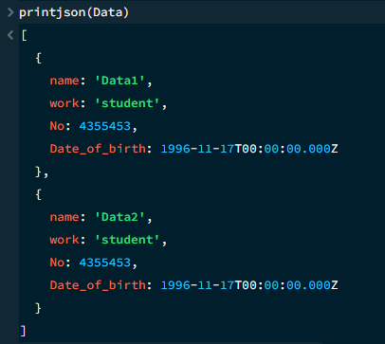

Exercises:

- Start MongoDB
- type mongosh to start mongo shell
- To show the databases o show dbs
  - use <database name> will use and switch to that database. If there’s no database, this command will create one.
  - db will tell you current db
  - [Exercise] Create a database “Company”
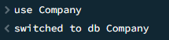
  - [Exercise] Create a database “University”
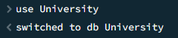
- [Exercise] Create user for the database “Company”
db.createUser(
{
user: "John", pwd: "1234", roles: [ "readWrite", "dbAdmin" ]
} ,
)
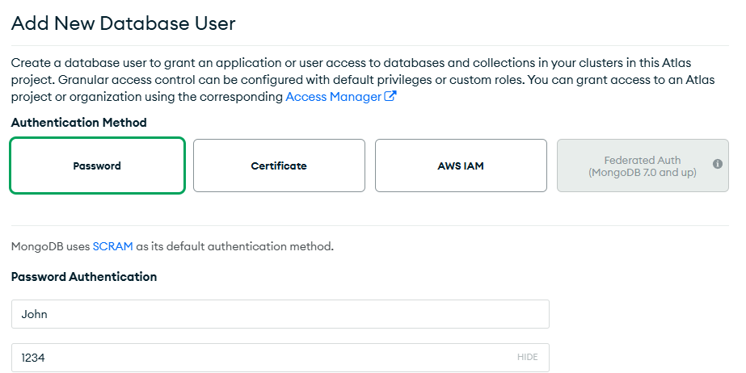
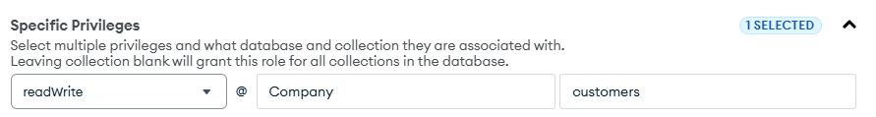
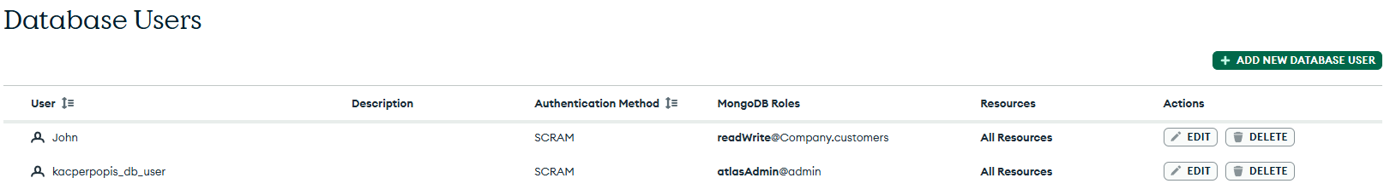
- [Exercise] Create a collection “customers” for Company database
o db.createCollection(‘customers’);
o show collections
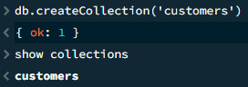

- Insert documents to collection
o db.customers.insertOne({first_name:"John", last_name:"Doe"});
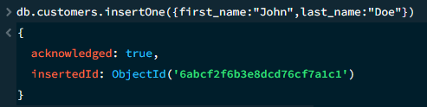
o [Exercise] Create 5 customers and the fields for their first_name and last_name: John Smith, Alicia Zelaya, Jennifer Wallace, Ahmad Jabbar, James Borg
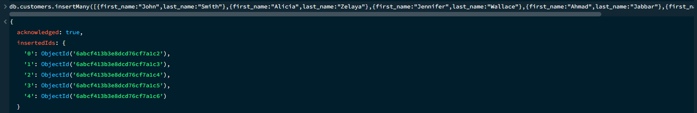

- Multiple documents at once using array format o db.customers.insertMany( [ {first_name:"Sam", last_name:"Smith"} , {first_name:"Jade", last_name:"Smith", gender:"female"}]);
- Import o Import json files to the database
- [Exercise] First download the file from and save it somewhere https://www.cs.odu.edu/~sampath/courses/f19/cs620/files/data/stocks.json

mongoimport --db tet4 --collection student1 --type json --file C:\Users\Admin\Desktop\stocks.json

In order to use the mongoimport first you should download and install MongoDB Database Tools, a collection of command-line utilities for working with a MongoDB deployment. https://www.mongodb.com/try/download/database-tools

